Disability, Landscapes and Nature:
Re-Storying Landscapes for Social Inclusion

Sarah Bell, Annette Eatock, Claire Eatock, Joanna Grace, Clare Hickman, Zoe Partington, Andy Shipley, Harriet West, and the staff and volunteer team at Westonbirt, The National Arboretum

May 2022

Contents
Summary 3
Introduction 8
Re-Storying Landscapes 9
Understanding disability 12
The medical model of disability 12
The social model of disability 13
The human rights model of disability 13
The affirmative model of disability 14
Differentiated experiences 15
Dismantling barriers 16
Physical site access 19
Proximity and access routes 19
Physical fabric of a setting 20
Quality of sensory experience 23
Language and interpretation 33
Preparing for a visit 38
Online familiarisation materials 38
Sensory access stories 39
Sensory history and social inclusion 42
Institutional inclusion 48
Additional resources 61

Summary
This guidance brings together a series of resources to support disability-inclusive, multisensory nature experiences. It is designed for anyone involved in the design, management and/or interpretation of a nature setting.
It shares learning and case studies developed within and beyond the ‘Re-Storying Landscapes for Social Inclusion’ collaboration. This was a project funded by the UK Economic and Social Research Council (2020 – 2022). It was led by Dr Sarah Bell at the University of Exeter, in collaboration with Art Shape, Zoe Partington, Andy Shipley of Natural Inclusion, Clare Hickman of Newcastle University, Westonbirt – The National Arboretum, Access Lizard Adventure and the Sensory Projects.
The overall aim of the project was to inform landscape decision-making that reflects and respects the diverse ways in which landscapes are sensed, valued and experienced over time. Understandings of nature and of disability are produced – and at times constrained by – prominent social norms and stories that promote particular ways to experience and ‘be’ within different nature settings. Sometimes these norms – and the landscape decisions they inform – are ‘disablist’ i.e. they discriminate against disabled people and ignore disability rights. Sometimes (often unintentionally), they are ‘ableist’ i.e. they prioritise the needs and preferences of non-disabled people at the expense of disabled people.
Through the project, we have been exploring creative, collaborative opportunities to dismantle disabling barriers to participation in landscape interpretation and decision-making; to make unseen or rarely felt qualities of nature more compelling across varied backgrounds, histories and life circumstances.
In part such efforts concern the physical fabric of a nature setting – its layout, gradients, distances, surface materials, ease of navigation, maintenance etc. – but it is also important to consider the quality of sensory experiences available and the sensory preparation that some people might need to access such experiences. These qualities might include, for example, opportunities to move freely and safely, to explore and to tune into the songs and calls of particular bird, insect or other animal species, flowing water, tree bark textures, scented plants, varying topography, microclimates, sensory ‘nooks’, ‘gems’ or ‘cocoons’.
Efforts should be made to ensure a range of people have the opportunity to identify and share their sensory experiences of a site, and in doing so facilitate new experiences for others. Working with artists – including disabled artists – is valuable in finding creative ways to support this, recognising the power of the arts (and particularly disability arts) in sharing new understandings of difference that open up new perspectives and possibilities.
It is also essential to consider the stories shared about a setting; whose stories are prioritised? Who is crafting those stories? How are they communicated? Who do they include and who do they erase? When disability access and inclusion are considered, it is often in the context of visitor access, rooted in the aspiration to create accessible experiences for disabled visitors. This narrow framing overlooks the role of disabled people as curators of experience – that is, as potential site volunteers, storytellers, writers, communicators, education and visitor experience officers and managers. Efforts to embrace and embed diverse experiences, perspectives and skills within the staff and volunteer base can enhance the potential to identify and facilitate experiences that resonate amongst people with varied sensory, social and cultural backgrounds.
Insights from sensory history can also create new opportunities to tell often overlooked stories that might be more relatable and accessible, helping people from varied backgrounds to find ways into their own landscape experiences. Sensory history reflects on the role of the senses in shaping people’s experiences of the past, including how people used, engaged and interacted with past landscapes. How might lesser-told stories – for example, those identified within the diaries of people who worked within, managed and cared for a landscape in the past – resonate for people today? What might it have been like for disabled people to experience the landscape historically?
It can take time and practice to think differently about how to embed meaningful access and inclusion. It is worth noting that individually and organisationally, if you have not experienced an access issue (i.e. had lived experience of it), you may not know what or where the barrier is, or in what contexts it may be encountered.
It is important to listen to and address the barriers, access requirements and priorities that disabled, neurodivergent and D/deaf people – including visitors, volunteers and/or staff members – explain and share with you. Different people will have varied experiences of disability. These experiences may be shaped by specific impairment effects but also by life experiences, social relationships and wider forms of inequality, for example, in relation to age, gender, class, race, ethnicity and sexuality. Remember, accessibility is about adaptability – taking time to understand and accommodate people’s individual adjustments is essential.

Introduction
In October 2021, the United Nations Human Rights Council recognised, for the first time, the universal human right to a healthy environment. This includes rights to healthy biodiversity and ecosystems, non-toxic environments to live, work, study and play in, a safe climate, clean air and safe water.
With growing awareness of the health and wellbeing benefits of time spent in ‘nature’ – from the elements encountered while pottering outside, to gardens, parks, woodlands, countryside and coastlines – it is essential that opportunities for such experiences are open to everyone.
While many people experience nature as calming, nourishing or invigorating, it can also be unpredictable, uneven and challenging to negotiate. Narrowly defined norms about how to engage with nature can also create experiences of exclusion and marginalisation amongst people whose priorities diverge from these norms.
If we are to fully understand and enable experiences of health and wellbeing with nature, we need to appreciate and respect the plurality of ways to be well with nature in all its forms.

Re-Storying Landscapes
This guidance brings together a series of resources to support more socially inclusive, multisensory nature experiences. It is designed for anyone involved in the design, management and/or interpretation of a nature setting.
It shares learning developed within and beyond the ‘Re-Storying Landscapes for Social Inclusion’ collaboration – a project led by Dr Sarah Bell at the University of Exeter in collaboration with Art Shape, visual artist and creative consultant Zoe Partington, Andy Shipley of Natural Inclusion, Clare Hickman of Newcastle University, Westonbirt – The National Arboretum, Access Lizard Adventure, and Joanna Grace of the Sensory Projects.
The overall aim of the project was to inform landscape decision-making that reflects and respects the diverse ways in which landscapes are sensed, valued and experienced over time.
In part such efforts concern the physical fabric of a nature setting – its layout, gradients, distances, surface materials, ease of navigation, maintenance etc – but it’s also essential to consider the stories shared about a place; whose stories are prioritised? Who is crafting those stories? How are they communicated? Who do they include and who do they erase?
As noted by project collaborator, Andy Shipley:
“I think the invitation to all of us is to explore and discover the diverse ways in which sites and habitats behave and express themselves so we can work with them to reveal and share their unique and distinct stories, to delight and enchant all who encounter them”.
Through the Re-Storying Landscapes project, we have been exploring creative, collaborative opportunities to dismantle disabling barriers to participation in landscape interpretation and decision-making; to make unseen or rarely felt qualities of nature more compelling across varied backgrounds, histories and life circumstances.
The project was funded by the UK Economic and Social Research Council Impact Acceleration Account from 2020 – 2022. It builds on the ‘Sensing Nature’ research project, led by Sarah Bell from 2016 – 2018. It also draws on discussions developed as part of ‘Unlocking Landscapes’, a network funded by the Arts and Humanities Research Council from 2020 – 2022.
You can find out more about this work online at: www.sensing-nature.com and https://www.unlockinglandscapes.uk/

Understanding disability
There are many ways of understanding disability, which have implications for efforts made to promote social inclusion across diverse nature settings.
People often refer to specific ‘models’ used to understand what disability is, including (bio)medical, social, affirmative, biopsychosocial, charity, cultural and human rights models, to name a few.
Here we briefly summarise four of the main models you might come across:

The medical model of disability
The medical model of disability presents disability as an individual, medical 'problem'. It focuses on what a person cannot do, attributing these limitations to individual physical, neurological or psychological characteristics. The medical model suggests people are disabled by their impairments. It typically centres cure, rehabilitation and welfare as ‘fixes’, and implicitly places responsibility on the disabled individual to change. The medical model primarily looks at what is 'wrong' with the person, rather than recognising deeper social and environmental barriers to societal participation. It can undermine engagement, create low expectations and lead to people losing autonomy, choice and control with the onset and/or progression of impairment.

The social model of disability
The social model of disability was developed by disabled people to identify and act against discrimination and prioritise social justice. The social model makes a distinction between impairment (a condition, illness or compromised embodied function) and disability (societal barriers and discrimination). It recognises disability as socially created and demonstrates that people with different impairments may face common problems e.g. lack of access to information and communication, environmental exclusion and discrimination in employment. The social model seeks to empower disabled people, along with their allies, to find common solutions to dismantle these barriers. It moves away from a position of locating shortcomings within a disabled individual and argues that impairment is and always will be present in society. It suggests that the logical outcome is to plan and organise society in a way that includes, rather than excludes, disabled people.

The human rights model of disability
The human rights model seeks to bring disabled and non-disabled people together as part of a wider human rights movement underpinned by a shared sense of humanity, respect for human difference and dignity, and a commitment to positive social change. Although narrower in scope, it complements the social model in providing guidance on policy responses to disability with the aim of advancing social justice with and for disabled people (it has therefore been called a model of disability policy rather than disability by some). The human rights model seeks to progress disability policy and law in ways that align with principles set out in the UN Convention on the Rights of Persons with Disabilities (CRPD), working in collaboration with disabled people’s organisations (DPOs).

The affirmative model of disability
The social model of disability has been paramount in shifting the focus from medicalised, individual bodies to the exclusionary disabling qualities of physical and social environments, policies and practices. However, it tends to convey disability primarily as an oppressive, restrictive social relationship. Without wishing to deny these negative experiences of impairment and disability, the affirmative model seeks to balance such approaches with a non-tragic view of disability and impairment, which encompasses positive social identities, both individual and collective. It recognises impairment as an ordinary part of human existence to be expected and respected on its own terms.

Differentiated experiences
A key point to remember is that different people will have different experiences of disability. These experiences may be shaped by specific impairment effects but also by life experiences, social relationships and wider experiences of inequality, for example, in relation to age, gender, class, race, ethnicity and sexuality. Do not rely on stereotypes as a proxy for people’s needs or interests. It is important to take time to get to know people as individuals, to ask if they would like any adjustments and to listen and adapt as necessary. Notably, adjustments needed may change over time or within different social or environmental conditions. Do not ask people questions about specific impairments or conditions – they may offer this information, but your focus should be on the adjustments required for meaningful participation as expressed by each individual.

Dismantling barriers
It can take time and practice to think differently about how to embed meaningful access and inclusion. It is worth noting that individually and organisationally, if you have not experienced an access issue (i.e. had lived experience of it), you may not know what or where the barrier is, or in what contexts it may be encountered.
It is important to listen to and address the barriers, access requirements and priorities that disabled, neurodivergent and D/deaf people – including visitors, volunteers and/or staff members – explain and share with you.
When thinking about barriers, try to move beyond the identification of a barrier to reflect on how you might resolve the barrier. Be focused about this, e.g. using SMART objectives:
- Specific - how will it be resolved?
- Measurable – how, by who and at what intervals to monitor change?
- Achievable – with the budget/resources you can access.
- Relevant – to the barrier identified.
- Time-constrained – put a timescale on your intended actions.

An equalities impact assessment tool can help in defining what the barriers are and how they can be addressed, mapping what needs to be changed to improve how everyone experiences and contributes to a setting.
Remember, accessibility is also about adaptability – taking time to understand and accommodate people’s individual adjustments is essential.
When reflecting on potential barriers across nature settings, it can be helpful to reflect on physical, sensory, intellectual, social and institutional qualities of access and experience. In this guidance we reflect on these qualities in the context of physical site access, sensory experience, language and interpretation, advance information pre-visit, and wider dimensions of social and institutional inclusion.
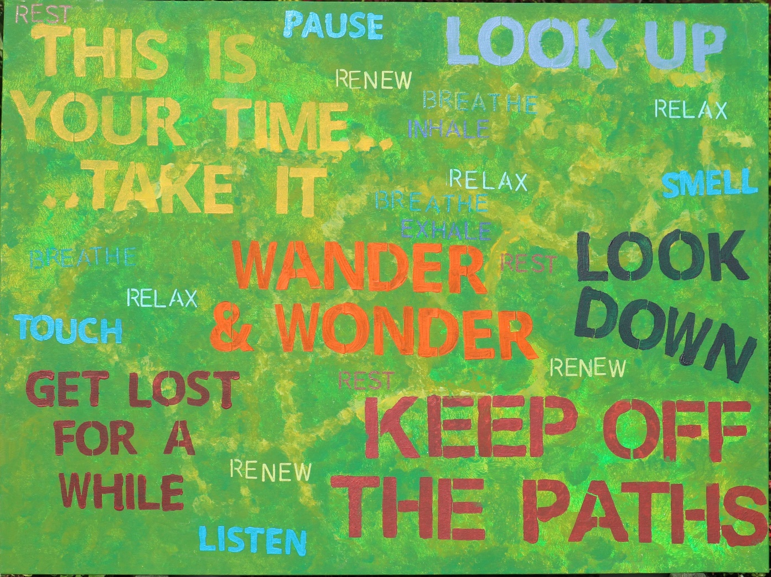
Image: “Keep Off the Paths” by Sarah Goddard
Image caption: ‘Keep Off the Paths’ is a large landscape-orientation acrylic painting by visual artist, Sarah Goddard, with an abstract green background covered in stencilled writing in red, orange, yellow and blues. The background is painted in loose dabbed brush-strokes of bright greens, with more yellow marks to represent a map of the paths running through Westonbirt Arboretum. There is text stencilled in different colours and sizes across the painting. The text reads: “Keep off the paths” in red. “Get lost for a while” in red. “Wander and Wonder” in orange. “This is your time… … take it” in yellow. “Look up” in pale purplish-blue. “Look down” in dark blue. “Pause”, “Smell”, “Touch”, “Listen” in pale blue. “Renew, relax, breathe, inhale, exhale” multiple times in smaller font in shades of blues and yellows. This painting was inspired during the ReStorying Landscapes project by a desire to encourage visitors not to treat the Arboretum as a formal garden, where they might be expected to keep to the paths, but rather to get close to the trees, to walk among them and gain as much as possible from the experience of being in nature. Credit: Sarah Goddard.

Physical site access
When nature access is considered, it is typically in terms of physical access, including considerations of proximity, access routes and the physical fabric of a setting.

Proximity and access routes
Some nature settings can be challenging to reach without access to private transport. In the UK, this is particularly apparent in rural areas and in the case of specific historic landscapes (e.g. country house estates and parklands) that were developed when economic power was concentrated in the countryside. Such ‘exclusive’ settings were often deliberately located in more remote rural areas to be less accessible to others.

Contemporary bus services to these landscapes are often infrequent (if available at all) and may involve multiple changes to reach the desired location. In these cases, it can be valuable to explore opportunities to link up with community transport providers if available, develop volunteer driver pools, or explore the potential to operate shuttle buses in collaboration with nearby visitor sites/attractions. Greater effort is needed to identify transport strategies that will reduce multiple car use and enhance the ease of accessing such settings for all.

Physical fabric of a setting
Once on site, it is important to examine:
- Ease of navigation from the entrance(s) onwards.
- The scale and layout of a setting.
- The quality of path networks, considering distances, gradients, surface materials, path widths, presence of steps, ramps or other obstacles, tactile hazard warnings, handrails etc.
- Presence and distribution through a site of key facilities e.g. toilets, Changing Places, resting places, refreshments etc.
- Site maintenance, reflecting on how different parts of the site ‘weather’ through the seasons and the need to address any drainage issues or ephemeral trip hazards.

In areas deemed historically or ecologically sensitive, concerns about ‘protection’ or ‘conservation’ can come into tension with opportunities to adjust the physical fabric of a setting to enhance access.
However, as noted by prominent disability scholar, Alison Kafer, exploring the potential for such adaptations:
“doesn’t mean that every single trail will accommodate every single body; there will be terrain too rocky or too steep for some bodies and modalities. But this is true for all bodies, disabled and non-disabled. What shifts in this view is that trails are no longer designed for only one single body and that decisions about trails are recognised as decisions, ones that can be changed, extended, modified”.
It can be valuable to explore creative opportunities here e.g. the use of boardwalks rather than paths over more fragile areas of land, or the availability of human guides or equipment to enhance access rather than just physical fixtures within the landscape. An example of such efforts is included in Box 1, the ‘Wild Way’ Kermeter Trail in Germany’s Eifel National Park.
…………………………………………………………………………………………
Box 1. The ‘Wild Way’ Kermeter Trail, Eifel National Park, Germany
The ‘Wild Way’ Kermeter Trail in the Eifel National Park, Germany, is a 6.2km accessible trail that criss-crosses a range of sensory-rich environments at the ‘ecological’ heart of the park. The trail encompasses a barrier-free network of paths, board walks and panoramic views of the lakes. It wends through mixed woodland containing native red beeches, with regular benches, and wheelchair-accessible picnic tables.
Ten interactive stations provide information about the wilderness, forest development and biological diversity within the Eifel National Park. In addition to thinking carefully about the physical fabric of the site, the trail incorporates a range of different approaches to orientation and interpretation, including large raised-type signage, German Braille and audio information, that can be located by following a tactile guidance system along the route.
More information about the Wild Way Kermeter Trail is available online: https://www.nationalpark-eifel.de/en/experience-national-park/barrier-free-accessibility/fully-accessible-wild-kermeter/
…………………………………………………………………………………………

Quality of sensory experience
Beyond enabling someone’s presence on site, it is essential to consider the quality of sensory experiences available e.g. opportunities to move, to explore and to tune into the songs and calls of particular bird, insect or other animal species, flowing water, tree bark textures, scented plants, varying topography, microclimates, sensory ‘nooks’, ‘gems’ or ‘cocoons’.
As highlighted by Jane Stoneham, Director of the Sensory Trust:
“Our senses connect us with the world around us. Our brains work out the meaning but are fed the information through a radar network of senses. We differ in the ones that each of us can use, but all of us are incredible sensory investigators. And yet when we come to designing our environments, vision so often steals the show. How can we be so wonderfully sentient in our day to day lives, and yet fail to reflect that when it comes to creating the spaces and experiences that are supposed to engage us? Embracing the diversity of senses is an excellent way of embracing diversity of people. We can design and interpret our spaces to be technically accessible, but if we miss the opportunity to respond to the sentient make-up of human beings, aren’t they unlikely to become the places and experiences we wish they were?”
To explore the multisensory experiences that visitors to a setting may tune into, it can be helpful to close your eyes and immerse yourself in a particular spot in situ. You might like to do this in varied weather conditions and through the seasons to experience the changing sensations.
Find your spot.
Get comfortable, feel your weight sinking towards the ground. Notice gravity’s pull.
Focus your attention on the space immediately around your body, a few centimetres away from your skin.
- What sounds are close to you?
- Maybe you can feel the breeze brushing your face or cooling your skin.
- Maybe the breeze is carrying a particular scent?
- How does the ground feel underneath you?
Now expand your awareness within a radius of around two metres…
- What sounds are unfolding around you? … in front, behind, to your sides, above and below?
- Can you hear any interactions in the soundscape, between birds or other animals perhaps?
- Any patterns in the soundscape?
- A scent teasing your nostrils?
Now extend your attention further, to about 50m in all directions…
- What do you notice?
- Sounds?
- Scents?
- Temperature changes?
- Any other sensations?
Now extend your attention towards and perhaps beyond the horizon…
- What sounds does that encompass?
- Focus your attention high up into the sky. Perhaps allow in the absence of sound.
Reflect on how that whole process felt for you: What did you notice in yourself and about the setting? How did you feel?
As demonstrated below in Boxes 2 and 3, efforts can also be made to ensure a range of people have the opportunity to identify and share their sensory experiences of the site, and in doing so facilitate new experiences for others. Working with artists – including disabled artists – is valuable in finding creative ways to support this, recognising the power of the arts (and particularly disability arts) in sharing new understandings of difference that open up new perspectives and possibilities.
…………………………………………………………………………………………
Box 2. ‘Potter and Ponder’, National Trust Croome, Worcestershire, UK
Set at National Trust Croome in Worcestershire, UK, a ‘Potter and Ponder’ sensory map was co-produced with children with learning difficulties from local schools and William Hanekom, an artist from ‘Outside In’ – an organisation providing a platform for artists who experience disabling barriers to the art world. It was funded by the Heritage Lottery through the ‘Capability’ Brown 300 Festival.
The map reflects moments of ‘sensory joy’ unfolding across the parkland, as highlighted by the 35 children who took part. Teachers from the children’s schools used a variety of communication tools and translation methods to ensure that all children clearly made their sensory choices; through tracking smiles, eye movements, gestures and dwell time.
The Artist, William, visited Croome’s sensory sites and created illustrations to represent the selected moments. William’s illustrations have been placed on Croome’s site map. In this way, the children’s experiences are now informing lots of people’s experiences on site – guiding visitors to discover and share in those moments of sensory joy.
The map illustrates a birds-eye view sketch of the National Trust Croome landscape depicting the key trails, garden layouts, rivers, trees and buildings with suggested sensory experiences set over the map in circles. Each circle has an illustration to convey the suggested sensory experience. The experiences include: Relaxing space – relax here for a while; Feel – feel the grass between your toes; Interaction Space – a place to play; Terrain – feel different surfaces and tree stumps; Ponder – a place to stop and think; Echo – make a sound; Listening – listen carefully you will hear lots of different sounds; Smell – travel down the hill there are plenty of things to smell; Light and Shade – feel the rope enjoy the light and shade; Making Choices – which cake would you choose?; Seeing – experience the view and landscape; Touch – touch the leaves and tree trunks. Credit: National Trust Croome.
A Makaton key was also produced for the map, with Makaton symbols linked to William’s images. One of these Makaton symbols (light and shade) was newly created for this purpose; reflecting the value of such initiatives for expanding the vocabulary available in Makaton to capture and communicate these more subtle sensory nature experiences.
You can read more about Potter and Ponder online: https://www.nationaltrust.org.uk/croome/features/potter-and-ponder-a-sensory-experience
…………………………………………………………………………………………
Box 3. ‘Fragile with Attitude’, Westonbirt – The National Arboretum, Gloucestershire
‘Fragile with Attitude’ was an art exhibition developed as part of the ‘Re-Storying Landscapes for Social Inclusion’ project, curated by contemporary artist and creative consultant, Zoe Partington, in collaboration with Westonbirt Arboretum, Art Shape and six fantastic artists.
Art Shape is an organisation that is passionate about supporting and enabling artists facing disabling barriers to realise their creative and learning potential. Westonbirt Arboretum is a national arboretum in Gloucestershire, UK, that was initially planted in the Victorian ‘plant hunting’ era of the mid-19th Century.
Working alongside the six artists, Zoe embedded the principles of the social model of disability in the development and curation of the exhibition. Through a series of workshops onsite and online, each artist found creative ways to ‘re-story’ the landscape through their own unique experiences.
Zoe explained:
“Disability Art is art made by disabled people, drawing upon a lived experience of disability. Disability Art has been recognised as a crucial component of the disability rights movement, informed by the social model of disability.
Disability Arts is about disabled people joining together. Through nurturing an affirmative self-identity, it gives us the confidence to promote the social change we want to see happen.
Creative interaction between disabled people involved in politics and disabled people involved in the arts fosters a collective identity, creating a new disability culture.
Proving that able-bodied people are not our role models. Providing control in how we are presented to others – a rounded picture of the reality of our lives. A celebration of difference”.
As a disabled artist and curator, Zoe emphasised the value of facilitating these artistic workshops in situ to enable disabled people to build landscape familiarity. The creative process can help to manage stress, anxiety and the unfamiliar in a non-conventional way. Disability Art is about flourishing in an environment that can benefit one’s identity and wellbeing. It enables each person to validate who they are, understand their human rights and avoid internalised ableism. Disabled people being visible, not only visually but intellectually, can help to break down institutional and societal barriers to participation.
Westonbirt is home to around 100 threatened tree species, including some of the rarest, ‘critically endangered’ species such as the sapphire dragon tree and Madeira mountain ash tree.
Recognised as ecologically fragile, the lives of each individual tree at Westonbirt are celebrated as symbols of hope, as sources of shelter, oxygen, food – an integral part of the wider ecosystem.
Yet, so often – and particularly since the Covid-19 pandemic – human lives deemed fragile are viewed as vulnerable or damaged. With illness, impairment and disability comes an assumption of inability, of a unique and separate form of weakness.
Rather than countering the social injustices that create unnecessary situations of vulnerability, disabled people are often segregated, pitied or dismissed.
In the words of influential scholar, Sara Ahmed:
“We need to develop a different orientation to breaking. We can value what is deemed broken; we can appreciate those bodies, those things, that are deemed to have bits and pieces missing. Breaking need not be understood only as the loss of the integrity of something, but as the acquisition of something else, whatever that else might be”.
Recognising this, ‘Fragile with Attitude’ encouraged people to recognise more affirmative understandings of disability rooted in strength, collective experience and expertise.
Reflecting on the experience, one of the artists, Sarah Goddard, explained:
“I have felt like an imposter, as many of us do, whatever our field. But being a visually impaired visual artist has felt oxymoronic and something I should hide. However, while working with other artists who face disabling barriers, I didn’t feel like the odd one out, having to explain access needs. This made me feel at ease, and freed me to concentrate on art from the start. Then throughout the project I came to further embrace my identity as a visually impaired artist, and I believe that this has enabled me to create more authentic work. I am building on this to create art that more closely reflects how I experience the natural world”.
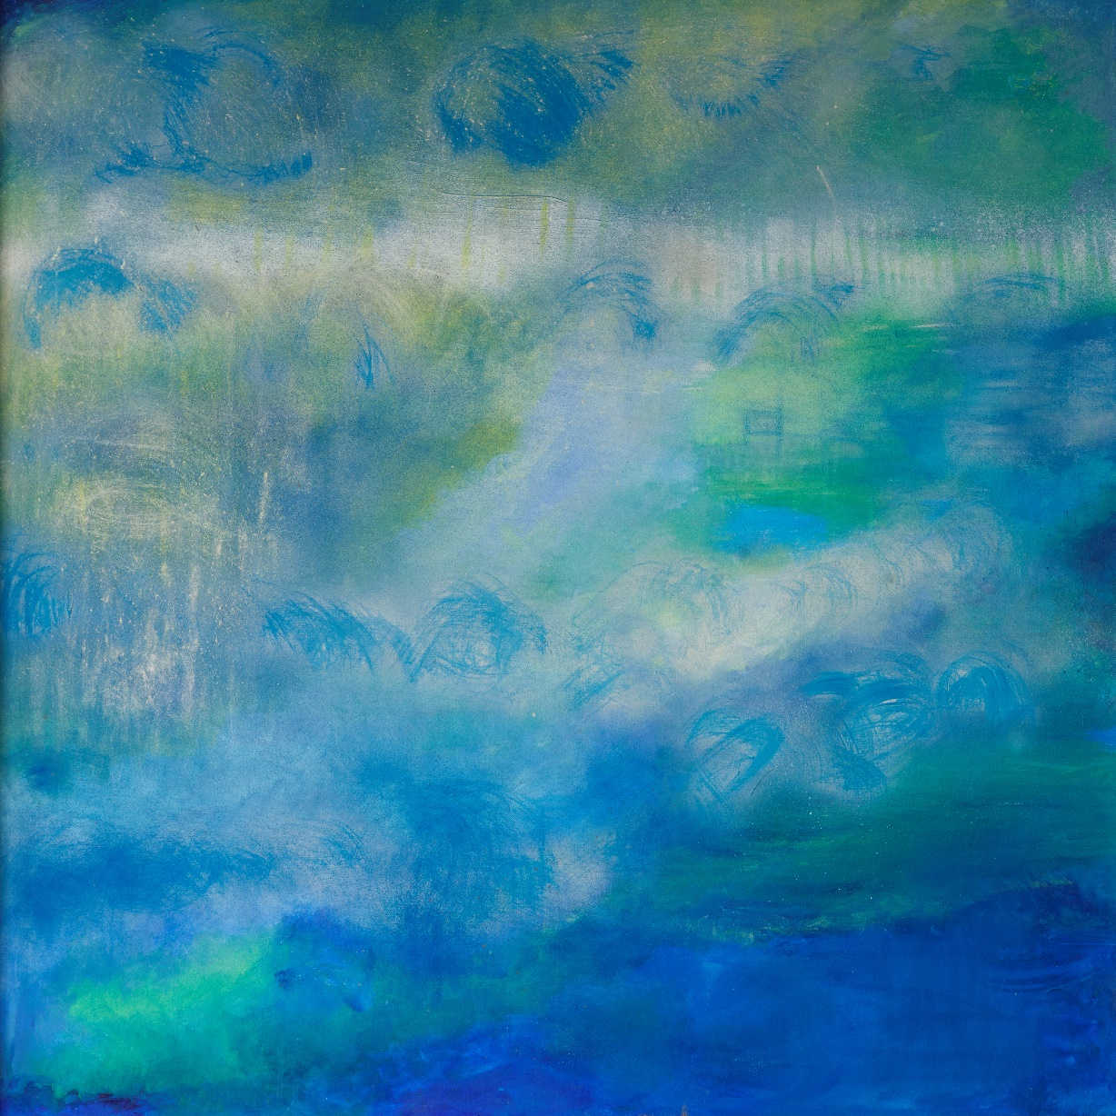
Image: “Blue Mist in the Air” by Zoe Partington
Image caption: ‘Blue Mist in the Air’ by exhibition curator, Zoe Partington. Acrylic paints, freely applied in swirls of greens and blues cover the entire surface of this canvas, which measured approximately 1 metre square. The colours have the intensity of a peacock’s feathers, overpainted with chalky white, moving down to a dark patch of cobalt blue in the lower right-hand corner, so that the lighter colours above appear to hover. Traces of textured brushwork whip up the surface, scratched with fine lines and dizzying circles. The effect is mesmeric. Zoe calls this image “Blue Mist in the Air” but it could equally be the surface of a pond dappled with lily-pads reflecting blue skies above. Credit: Zoe Partington.

Language and interpretation
Although not always possible (e.g. in smaller nature settings with limited investment), appropriate interpretation on site is important, both to support wayfinding and orientation but also for intellectual access – to share the historical, ecological and socio-cultural stories of a setting in an inclusive way. In part this is about the modes of communication used to share these stories. For example, is there scope to move beyond the use of fixed visual information boards to consider additional materials:
- Large print handouts, with clear colour contrasts.
- Tactile information (e.g. Braille, tactile maps, models).
- Audio description – from recorded descriptions of selected site highlights to podcasts, live tours, in situ listening posts/beacons/mobile apps, learning resources, and in social and print media.
- QR codes (or similar technologies such as ‘NaviLens’) linked to fully accessible online information.
- Sign language (and captioning for any audio-visual media).
- Makaton (use of symbols, signs and speech to support communication).
- Easy Read (a written format using simple words, short sentences and incorporating appropriate pictures to explain the words).
- Widget (a symbol-based written language used as an alternative or an accompaniment to text).

Where interpretation is fixed, it is important to reflect on where it is located:
- Will the clarity of the information be affected by weather conditions e.g. glare in bright light for visual materials, masking in strong winds for audio materials, loss of clarity of tactile materials in wet weather?
- Is there a risk of encountering obstacles while trying to reach fixed signage (e.g. collision hazards or overgrown nettles, brambles and thorns)?
- Are signs located at head height for walkers and/or wheelchair users?

It’s also worth reflecting on the skillsets and awareness of any staff and volunteers on site e.g. do people have sighted guiding skills? Do they feel confident with audio description? Can anyone on site communicate using BSL (British Sign Language) or Makaton?
Beyond these specific communication skills, it is essential to ensure people feel comfortable talking about access adjustments and disability more widely. Language is important here; it helps to avoid misunderstanding and offence. The most important thing to remember is… don’t panic!
Use language that is:
- Descriptive e.g. wheelchair user, long cane user, guide dog owner.
- Understandable e.g. visitor with a hearing or speech impairment.
- Simple i.e. avoid unnecessary adverbs like ‘severely’, or comments about ‘levels of functioning’. They might mean different things to different people.
- Not emotive i.e. do not use the phrases ‘suffering from…’ or ‘victim of…’ or ‘wheelchair bound’. If unsure, it can be helpful to describe people as having ‘experiences of’ disability, or being ‘wheelchair users’.
- Respectful – be guided by disabled people and their preferences. Do not undermine people’s sense of personhood by using terms like, ‘the disabled’ or ‘the elderly’. Depending on the context, it may be more appropriate to use terms such as ‘disabled people’ or ‘older adults’ in such instances.

A common query raised concerns the use of the terms ‘disabled person’ (identity-first language) or ‘person with a disability’ (person-first language). In the UK, disabled people’s organisations (DPOs) will tend to use identify-first language to emphasise that people are disabled by society and exclusionary environments, policies and norms – in line with the social model of disability.
The UNCRPD uses person-first language but recognises that ‘disability is an evolving concept and that disability results from the interaction between persons with impairments and attitudinal and environmental barriers that hinders their full and effective participation in society on an equal basis with others’ (Point 6 in the Preamble to the UNCRPD).
Context and intention are important in how language is used e.g. rather than suggesting someone has mobility challenges, you could explain that a particular setting can pose mobility challenges such as uneven paths, steep gradients etc. Rather than talking about access for a certain type of person, you might explain efforts to remove disabling barriers on site through the provision of large print, the availability of someone onsite with BSL or Makaton skills, the use of audio description, the production of podcasts etc. When describing facilities, it is better to refer to ‘accessible’ or ‘adapted’ toilets and ‘accessible’ or ‘blue badge’ parking facilities rather than ‘disabled toilets’ or ‘disabled parking’.
Most importantly, when in situ – take the lead from the visitor in question and be open and adaptable to change the language you use, based on their suggestions and preferences.

Preparing for a visit
To visit a site for the first time can be daunting if people do not know what to expect. If possible, always provide contact details online for people to get in touch in advance of a visit to discuss any access requirements, and ensure the person answering the query is knowledgeable, approachable and aware of all the options.

Online familiarisation materials
It is helpful to provide familiarisation materials online in a range of formats to enable people to get a sense of a site and prepare prior to visiting.
These materials may include:
- Descriptive information and images (with written descriptions) about the types of details noted above e.g. physical layout and fabric of a site, forms of interpretation etc.
- Information about how someone might access a site e.g. which entrances are closest to different forms of public transport (if available), how these link with surrounding path networks, and useful landmarks for finding an entrance on arrival.
- An indication of the forms of support and resources that are available on site in relation to varied access and communication priorities.

Sensory access stories
For some people, the demands or anxieties of taking on board new sensory information can be overwhelming, preventing access to an experience altogether. It is therefore useful to explore more creative ways of preparing people for the sensory qualities of a visit. Such efforts may be particularly important for visitors with profound and multiple learning difficulties (PMLD).
One way to do this is to develop a sensory access story. Sensory stories can provide a chance to rehearse experiences before a visit, taking time in a safe and familiar environment to explore sensations that may otherwise feel challenging. Experiencing a sensory story can help to orientate a person, enabling them to tune in their sensory systems and map out what will happen when they visit. Knowing what to expect can help to alleviate anxieties and support someone to get more out of the nature experience when they do visit.
In sensory stories, each concise sentence of a story is partnered with a rich and relevant sensory experience, for example sight, sound, touch, scent, proprioception, balance or movement etc. A sensory story rarely has more than 8-10 sentences in total. The sentence gives an audible clue that something is about to happen. Upon completion of the sentence, the focus switches to the delivery of the sensory experience, taking care not to detract from it with over-narration or by initiating multiple sensory processes at once. One sensory experience can cancel out another if the brain is receiving too much information. The pace of delivery of each sensory experience can be tailored to the processing priorities of the story participant, taking time to be in the sensory moment together.
In the ‘Re-Storying Landscapes’ project, we developed an example of a sensory access story for kayaking. The story takes the story participant through the sequence of getting ready to go kayaking, crossing to the water and boarding the kayak. Our story has an extra twist – the words also form the verses of the lyrics of a sea shanty, composed by music therapist, Liz Eddy, and sung by The Include Choir. So, people may choose to sing it as a sea shanty, or to simply use the shanty chorus as a way of signalling the beginning and end of the story. The story and shanty are available online: https://sensing-nature.com/news/kayaking-a-sensory-story
You can find more examples and practical resources for developing and delivering sensory stories via the guidance produced by the Sensory Projects: https://www.thesensoryprojects.co.uk/sensory-stories
Notably, like the types of stories and books we might read on a routine basis, it’s great to have lots of different sensory stories and varied genres of sensory story – so we might have sensory access stories for different types of nature setting or encounter. But we might also have sensory stories that capture people’s experiences on site – stories that:
- Resonate across the senses.
- Respect non-verbal communication and use different tools to share meaning.
- Can be shared and used to signal that people with diverse sensory and communication priorities are welcome and part of a setting’s wider story.

Sensory history and social inclusion
Understandings of nature and of disability are produced – and at times constrained by – prominent social norms and stories that promote particular ways to experience and ‘be’ within different nature settings, rendering people who deviate from these norms ‘out of place’ or ‘hyper-visible’.
It is important to consider whose stories about a place are told and by who. Who do they include and who do they erase? How are they communicated? There are social implications in telling particular stories (or prioritising particular experiences) and not others. In some cases, steps may be needed to acknowledge contested or hidden histories about a site – or the sourcing of species within it – and to recognise the impacts of these histories on who feels welcome and comfortable. The work of Historic England, the National Trust, and Kew Gardens on colonial histories is an important example of this from a wider social perspective (for example, see: https://www.houseandgarden.co.uk/article/decolonising-kews-botanical-collections).
Insights from sensory history can create opportunities to tell often overlooked stories that might be more relatable and accessible, helping people from varied backgrounds to find ways into their own landscape experiences. Sensory history reflects on the role of the senses in shaping people’s experiences of the past, including how people used, engaged and interacted with past landscapes. How might stories – for example, those identified within the diaries of people who worked within, managed and cared for a landscape in the past – resonate for people today? How might animals and birds have inhabited the landscape in the past and in what ways might they have enhanced or detracted from the sensory experience of humans? What might it have been like for disabled people to experience the landscape in the past?
Although not a nature site, per se, an interesting example from a disability perspective is that of Top Cottage in the United States, the home of Franklin D. Roosevelt. Due to polio, Roosevelt was a wheelchair user for much of his life; something he tried to keep invisible during his political career due to the stigma around disability at the time. Top Cottage was built (in 1939) with wheelchair accessibility in mind. Recognising this, Roosevelt’s wheelchair ramp and other disability-related artefacts are now very much a visible part of the site, used as key historic objects to open up conversations with visitors about disability and why Roosevelt hid his wheelchair use from public knowledge. This example raises questions as to all the other historic narratives and artefacts related to disability in the landscape which may have been overlooked or ignored. Are there opportunities within these histories to provide some sense of representation for more groups of people that have been excluded from such settings in varied ways over time?
…………………………………………………………………………………………
Box 4. Sensing History, exploring the archives at Westonbirt Arboretum, Gloucestershire
Archives and other historical sources can provide new ways of thinking about the past and interpreting it in more inclusive ways. To explore this potential further in the ‘Re-Storying Landscapes’ project, project partner Dr Clare Hickman visited the archives held at Westonbirt, the National Arboretum. The archive generally, and the specific set of boxes held on site at Westonbirt, might not seem an obvious place to look but other narratives and sensory experiences emerged from within the box of twentieth-century official work diaries and the National Insurance Act Accident book.
The physicality of different bodies was touched on within these sources. For example, although the Research Forester, Ted Leyshon, was mainly recording the day-to-day work within the site, there are also accounts of days and sometimes weeks he took off due to sickness in the 1950s. In some places these were noted as being due to lumbago or back pain. In one diary entry he records that he is given an Easter egg as well as a lumbago remedy by one ‘Mrs Dick’ who presumably lived locally. Here we find the shared experience and support of bodily conditions which also raises the question of what else might be in the archives if we looked? How might the stories of people in the landscape look different if we brought these narratives to the fore?
Both the diaries and the accident book also include reminders of occupational risks and working in the landscape. For example, one man is recorded as having cut off his thumb on the saw. This highlights the danger and risk when physically looking after and managing landscapes, which also provides a counterbalance to current arguments that frame such places solely in terms of positive health and wellbeing. It also is a reminder of the history of disability in relation to rural labour. Similarly, the recording of an adder bite highlights the complexities of the interrelationship between humans and non-humans in the landscape.
It is not just that we can find stories of rarely heard people if we look, but we can also think about sensory experiences of the past. In the archives there are stories of picking mushrooms and making rosehip wine which can provide different ways of sensing and connecting with place. This archival research informed the development (by project partner, Andy Shipley, and sound artist, James Bulley) of a ‘Sensing History’ sound installation at Westonbirt as part of the Re-Storying Landscapes project; an immersive outdoor art installation to explore and celebrate the multisensory histories and ecologies of Westonbirt. It aimed to inspire visitor imaginations about the diverse histories of the site and its inhabitants (human and otherwise).
The creation of the Sensing History sound installation at Westonbirt drew on much longer narratives of landscape and plant history but within it were sounds from the archive of the distant bell of the village that had been moved in the nineteenth century. This type of creative interpretation, which draws on sensory histories, provides a method of understanding the human shaping and use of the landscape in ways that can be more inclusive. It moves away from an exclusionary focus on seeing such places primarily as static pictures or aesthetic landscapes for visual appreciation, recognising them as multisensory working landscapes, often connected through their careful mix of species, to endangered landscapes all round the world.
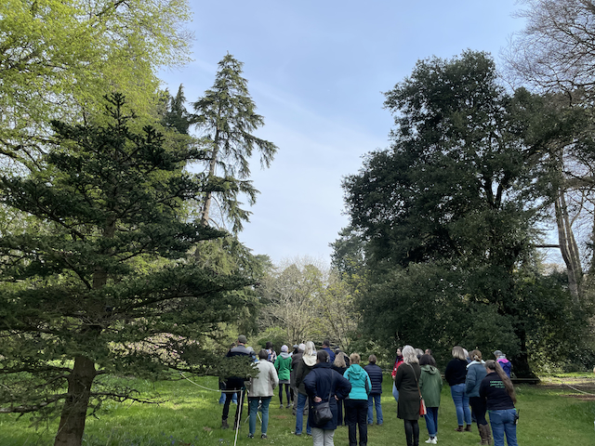
Image – Listening to Sensing History at Westonbirt Arboretum

Image caption: Delegates (30-40 people) at our Re-Storying Landscapes for Social Inclusion conference experiencing the initial part of the Sensing History sound installation amongst the trees at Westonbirt Arboretum with a hazy blue sky above. Speakers were installed at different heights through the trees and in the undergrowth, with the sounds unfolding around visitors through the journey. Credit: Dr Clare Hickman.

Institutional inclusion
When disability access and inclusion are considered, it is often in the context of visitor access, rooted in the aspiration to create accessible experiences for disabled visitors. This narrow framing overlooks the role of disabled people as curators of experience – that is, as potential site volunteers, storytellers, writers, communicators, education and visitor experience officers and managers.
Efforts to embrace and embed diverse experiences, perspectives and skills within the staff and volunteer base can enhance the potential to identify and facilitate experiences that resonate amongst people with varied sensory, social and cultural backgrounds.
Disability inclusion needs to be embedded into the mainstream of how an organisation thinks and operates, and organisations can be more ambitious about what can be achieved in close collaboration with disabled people. To do so, there may be central institutional processes to adapt alongside the access dimensions discussed above.
…………………………………………………………………………………………

Box 5. ‘Westonbirt Unseen’, Westonbirt Arboretum, Gloucestershire, UK
Through ‘Westonbirt Unseen’, we aimed to explore new ways of bringing disabled volunteers to the heart of visitor experience and interpretation activities at Westonbirt Arboretum.
During 2021, we recruited and trained four new visually impaired volunteers to join the existing volunteer guide team (as ‘VI Guides’) and develop ‘Sensing Nature’ walks; Mark Austen, Louise Rounds, Barbara Harris and Mike Kelly. Each VI guide was paired with a sighted assistant, and an assistant guide with responsibility for health and safety during the public walks. Together, the guides have explored and enabled new multisensory ways of experiencing and sharing the widely celebrated qualities and histories of the arboretum through the site’s popular guided walks programme.
The VI Guides ran their first programme of sensory walks on site in Autumn 2021 and went on to develop a new programme of sensory walks for 2022. Through these walks, the VI Guides have been enticing visitors off the main paths to explore the rich textures, sounds, scents and sensations of the arboretum. As commented by one visitor after joining one of the Autumn walks:
“New guided walks at Westonbirt offer a different way of experiencing autumn. Led by visually impaired guides and their lovely dogs, these walks encourage you to stop, feel, listen, smell and think. You might become aware of the earth and roots beneath your feet and the wind against your face, the rustle of the canopy or the chatter of children, the sharp citrusy smell of a leaf rubbed between your fingers, the knotty toughness of a branch. You might appreciate the astonishing dimensions of trees and develop a new sense of their form and structure. You might find words to record and retain your experience. All of this equals and enhances the conventional visual pleasure that most of us get from autumn at Westonbirt”.
Reflecting on the experience, volunteer guide Louise explained:
“Taking part in the project has been, and continues to be, a wonderful experience and a privilege. Westonbirt is a very special place, and being able to explore it every week as the seasons pass and the trees grow and change, has been a fantastic opportunity. The purpose of our walks is to take time to tune into the wonders of Westonbirt – which I am able to do on every visit. Our three aims are to: take time to awaken your senses in Westonbirt’s wonderful world of trees, use your senses to recharge and connect with yourself and nature, and to discover the essential role of trees in our lives. I experience these things week by week, and am honoured to be able to share this newly acquired passion with others. The team of Westonbirt Guides have been so welcoming, thoughtful, creative and enthusiastic in sharing their extensive knowledge and insights. One of the greatest outcomes for me has been the chance to work with other Visually Impaired people on a shared project – to exchange ideas and experiences, to support one another, and to become firm friends”.
Each stage of the project has revealed disabling barriers to participation, as well as creative opportunities to dismantle such barriers. Key learning points include:
Site access and familiarisation:
- With its rural location, reaching the Arboretum without access to personal or community transport is challenging. As a project team, we have been exploring opportunities to address these transport issues, but it remains one of the most significant access barriers.
- It was essential to embed plenty of time to build familiarity with the site as part of the guide training programme e.g. for route training, wayfinding and orientation. The guide training team produced valuable tactile resources to develop shared points of sensory reference e.g. hand-sized wood carvings to give a sense of the relative shape and size of different tree species on site; a collection of bark extracts, leaves and seeds from key species; and fabric embroidered tactile maps to gain an overview of the site and its key areas, path networks and landmarks. This project also benefited from the time and support dedicated to the project by the staff and large Westonbirt volunteer team during the early developmental and training stages.

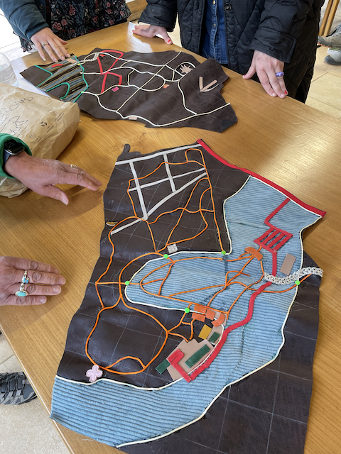
Image – Exploring tactile maps

Image caption: Two fabric tactile maps, of about half a metre in length, laid out on a wooden table in the Great Oak Hall at Westonbirt Arboretum, with the hands of the map creator, guide Pauline Thomas, nearby. Using brown, orange, red, white, blue and green colour contrasts, along with different fabric textures, the maps depict the main routes and landmarks of the Arboretum, providing an overview of the site and how different areas relate to each other. Credit: Dr Clare Hickman.
Guide training:
- Together, we reworked the existing volunteer guide training programme to embed an experiential in situ learning approach that did not rely on visual classroom-based presentations and activities. The training programme included key skills for guiding, as well as more factual content about the trees and history of the Arboretum. This adaptation occurred in close collaboration with the recruited VI Guides, working together to identify opportunities for meaningful in situ learning and exploring new ways of opening up the multisensory qualities of the site in engaging participatory ways.
- Onsite training sessions were complemented by short podcasts and accessible written materials (ensuring they were both screen-reader compatible and visually accessible for people with residual vision). Sharing of large files was difficult due to the inaccessibility of institutional web-based collaborative platforms and document transfer systems. USBs were useful here.
- An important learning point was to provide plenty of time for trainees to read and digest advance training materials prior to meetings/training sessions (it typically takes longer to process information via the use of magnifiers, screen readers or podcasts than it does to skim read). Ensuring a shared understanding from the outset of the time commitment involved was essential, alongside working together to develop a feasible timeline of activities around people’s wider commitments.
- Mandatory institutional volunteer e-learning training modules remained a challenge as they were heavily reliant on visual engagement and lacked audio description.

Trusted partnerships
- Characterised by mutual respect, it was essential to cultivate a supportive environment and trusted partnerships throughout this initiative, both during the training phases and in the walk planning, piloting and delivery phases. Thoughtful and regular communication is essential to ensure people feel safe in sharing what is or is not working and inspired to develop and refine ideas and approaches together.
- Trainers and trainees developed a strong sense of rapport, trust and mutual learning during the training process. It was important to ensure those relationships were sustained through the subsequent public walk design, mentoring, development and delivery phases to allow trusted relationships to develop and consolidate over time.
- It was also valuable to build in plenty of time and resource for trainees to develop and share their ideas together and maximise opportunities for peer support. In our project, the VI Guides initially developed and delivered their walks in pairs to build confidence together, before choosing to deliver both joint and separate walks at a later stage of the project.
- It was essential to ensure that the core group involved in a guided walk (i.e. the VI Guide(s), the sighted assistant(s) and the assistant guide) each knew the guided walk content and schedule fully before delivering it to the public i.e. avoiding last minute changes in sighted assistants or assistant guides if possible – both due to the trust involved in these relationships but also the comfortable shared knowledge that develops in these groupings of exactly where people need to be, when and why on the day.
- Recognising the relationships between guide dogs and guide dog owners, it was important to build in time for free runs throughout the process. VI Guides also included time to explain appropriate guide dog conduct to members of the public at the outset of the public walks.
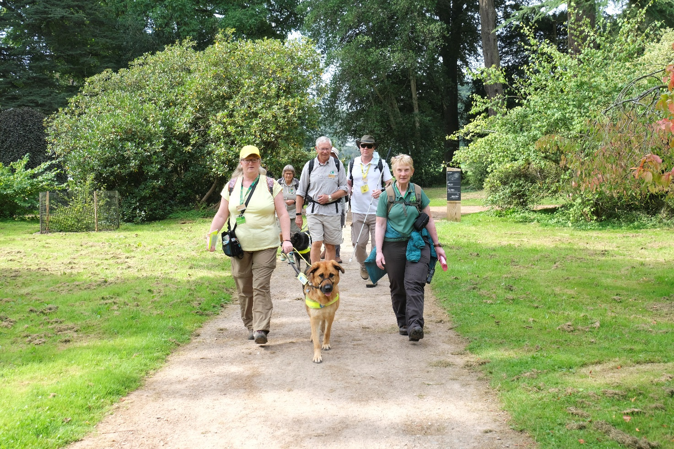
Image – A practice walk with the guide team

Image caption: The Westonbirt guide team during a practice walk. Louise Rounds and her guide dog Axel are upfront with Liz Hassall, the Westonbirt volunteer guide who led the VI guide training and mentoring programme. Behind Louise, Axel and Liz are Martin Green (a core member of the guide training team) and VI Guide Mark Austen. Behind Mark and Martin, are VI Guide Mike Kelly and Pauline Thomas (another core member of the guide training team and creator of the tactile maps). The group are walking along a wide path flanked by grass against a backdrop of trees in the Arboretum on a sunny day. Credit: Alison Cobb.

Managing risk:
- Although delayed by the Covid-19 pandemic, it was important that assistant guide volunteers were fully trained in sighted guiding techniques as part of the programme – to ensure VI Guides felt safe and supported as necessary during the training and later in the design and public delivery of their guided walks. It can take a while to build trust in one’s own guiding skills and in someone else’s guiding skills, and to understand people’s individual guiding priorities. Remaining fully focused as a sighted guide is important for navigating the terrain onsite, describing the layout and cleanliness of key facilities (e.g. bathrooms), and in ensuring that VI guides are always facing the audience while delivering a guided walk, and not left alone without warning.
- Care is needed to embed health and safety training into the programme, and to adapt risk assessment documents and processes accordingly e.g. ensuring lengthy risk assessment tables are converted into screen-reader accessible documents, and developing arrangements for risk assessment that align with the needs of the guide team. While the VI Guide(s) held leadership of the public walk overall, a sighted assistant guide took responsibility for health and safety aspects of the walk.

Reflecting on the process, Westonbirt’s Learning and Participation Manager, Ben Oliver, commented:
“The Re-storying Landscapes Project has once again demonstrated the value of welcoming and working with people with diverse experiences. By collaborating on the project we have grown our understanding about how every decision we take can create barriers to participation and the loss of personal agency. The value of listening carefully to individual life experiences and the constructive feedback provided by all those involved has been immeasurable. Though challenging at times, the result has been a project that has delivered significant new experiences for our visitors and supported our continued journey to becoming a more inclusive site”.
…………………………………………………………………………………………

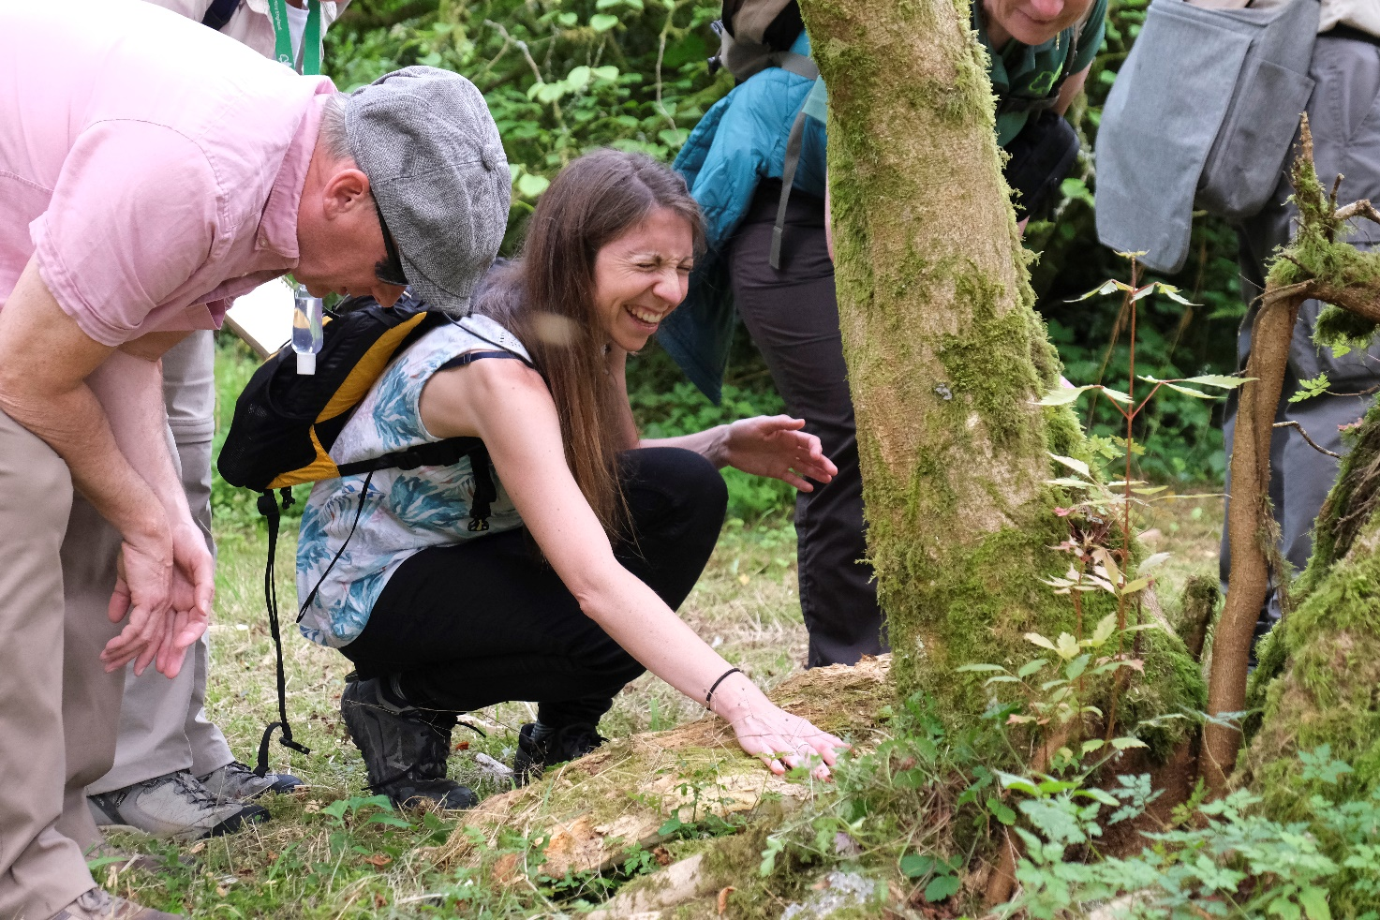
Image - Exploring tree textures at Westonbirt

Image caption: Photograph of project lead, Sarah Bell, and project partner, Andy Shipley, joining a practice sensory walk at Westonbirt Arboretum in September 2021. Sarah has her eyes closed as she explores the roots and textures around the base of a moss-clad tree trunk by touch, and Andy is bending over listening to the description. Behind the tree, mostly out of shot, are three other members of the guide team. Credit: Alison Cobb.

Additional resources
Additional information can be found via other resources that have been written to support inclusive nature access across a range of different needs and priorities:
Designing with sight impairment in mind: A guide produced as part of the Sensing Nature project, including ten top tips for designing green space with sight impairment in mind, promoting access with dignity and ensuring everyone feels welcome and supported. Available at: https://sensing-nature.com/news/designing-sight-impairment
By all reasonable means: Least restrictive access to the outdoors: A guide produced by the Sensory Trust in collaboration with, and on behalf of, Natural Resources Wales. Available at: https://www.sensorytrust.org.uk/resources/guidance/by-all-reasonable-means-least-restrictive-access-guidance#:~:text=Using%20the%20principle%20of%20Least%20Restrictive%20Access%20By,to%20encourage%20more%20action%20by%20managers%20and%20owners.
Easy access to historic landscapes: A guide produced by Historic England to demonstrate and celebrate access solutions that combine conservation with innovative design. Available at: https://historicengland.org.uk/images-books/publications/easy-access-historic-landscapes/heag011-easy-access-to-historic-landscapes/
Nature Narratives: A guide produced as part of the Sensing Nature project, in collaboration with VocalEyes, to support natural heritage sites in enabling inclusive multisensory nature experiences amongst people with sight impairment. Includes advice on sighted guiding and audio description. Available at: https://sensing-nature.com/news/nature-narratives-guidance
Walking for Health: A guide produced as part of the Sensing Nature project, in collaboration with British Blind Sport, Walking for Health and the University of Sussex, to enable people with visual impairments to take part in group-walking activities. Available at: https://sensing-nature.com/news/walking-guidance
Sensory Stories: A range of guidance documents produced by the Sensory Projects around sharing sensory stories, co-authoring sensory stories, and the many uses for sensory stories. Available online: https://www.thesensoryprojects.co.uk/sensory-stories
A range of creative activities produced by the Sensory Trust to engage the senses and connect with nature, including sound walks, nature palettes and texture journeys. Available at: https://www.sensorytrust.org.uk/resources/activities/p2

Acknowledgements
We would like to thank everyone who has enabled and contributed to the ‘Re-Storying Landscapes’ project over the last two years, particularly in the challenging context of a global pandemic.
Thank you to the funder, the UK Economic and Social Research Council Impact Acceleration Account, and the University of Exeter.
Thank you to the project team; Andy Shipley, Zoe Partington, Harriet West, Ben Oliver, Susanna Bayliss, Claire and Annette Eatock, Joanna Grace and Clare Hickman.
A big thank you to our Art Shape artists; Naomi Said, Lisa Barnfield (the Green Lady), Chloë of the Midnight Storytellers, Eleanor May (Cat in the Moon), Julia Nigh (Duck & Dot), and mixed media abstract artist, Sarah Goddard.
A huge thank you to our visually impaired volunteer guides, Mark Austen, Mike Kelly, Louise Rounds and Barbara Harris, and to the wider volunteer team at Westonbirt Arboretum for all their time, creativity and energy – to Liz Hassall for leading the volunteer training and development in collaboration with Angela Greenwood, Malcolm Potter, Pauline Thomas and Martin Green; to Alan Connor for mentoring and providing ongoing assistance in collaboration with Ruth Gillson, Neil Harvey, Rod Elliott, David and Rona Laycock, Sharon Bonson, Clare Gibbs and Annabella Scott; and to Westonbirt staff Claire Bradley, Hannah Griffiths, Louise Amato, Ally Cobb and Emily Burgin. Thank you also to the Friends of Westonbirt Arboretum for providing ongoing support for the initiative.
Last but not least, thank you to the Sensing History sound installation production team; sound artist James Bulley, technical production manager Ed Borgnis, script writer Imogen Robertson, and voiceover artist Michelle Newell.
European Centre for Environment and Human Health
University of Exeter
Knowledge Spa
Treliske, Truro
TR1 3HD
Cornwall

Email: Dr Sarah Bell
Sarah.Bell@exeter.ac.uk
www.sensing-nature.com

